# Scenario #4

## Scenario Description

* The odds in the game are incorrect. The game should have an approximate win : lose ratio very close to 0.42% (error < 0.01 over 10000 games).
* For example, if 10000 games are played in batch mode the win:lose ratio should be very close to 0.42%.

## Version Control

|  |  |  |  |
| --- | --- | --- | --- |
| Version # | Date | Author | Description |
| 0.1 | 18/10/2019 | James Bell | Initial Draft |
| 1.0 | 18/10/2019 | James Bell | Initial Version |

## Test Scripts

The following scripts will cover this scenario:

* 1.1 Test Script #1
* 1.2 Test Script #2

## Test Components/Requirements

This test scenario covers the following high-level test requirements (see scripts below for specific requirements covered by each test script):

* Component 1
* Component 2
* Functional Requirements Group 1

## Script #1

### Script Description

* Launch program in batch mode with any balance, bet limit and select any dice picture. The user can bet any amount with 10000 games. Once selected the game displays all games and the finally amount of the users balance which will bet lower or higher than expected.

### Testing Requirements

This test script covers the following specific testing requirements:

* Must be in batch mode.
* Have a balance of $10000.
* Bet an amount of 1.
* Bet limit must be 1.
* Any dice picture selected (e.g. Fish, prawn, rooster, crab, courd or stag).
* Must play 10000 games.

### Setup

* Must be playing batch mode.
* Must have a balance, bet limit, bet amount and amount of games above.

### Teardown

* List all steps that should be taken after the test case is executed

### Script Steps

| **Step #** | **Test Action** | **Expected Results** | **Pass/ Fail** |
| --- | --- | --- | --- |
| 1 | Launch program | Launches successfully | pass |
| 2 | Select b (batch mode) | Askes for player name | pass |
| 3 | Input player name | Askes for initial balance | pass |
| 4 | Input initial balance = 10000 | Askes for bet limit | pass |
| 5 | Input bet limit = 1 | Displays user info and askes for games amount | pass |
| 6 | Input games amount = 10000 | Askes for bet | pass |
| 7 | Input bet = 1 | Askes for pick | pass |
| 8 | Input s (standard pick) | Askes for symbol | pass |
| 9 | Input symbol | Displays games and final balance (final balance should be close to $5800) | fail |
| 9 | End test | End test |  |

### Test Execution

|  |  |  |  |  |
| --- | --- | --- | --- | --- |
| Date/Time | Tester | Test ID | Test Phase | Status |
| 17/10/19 11:00am | James Bell | James1 | System Cycle 1 | Passed |
| 17/10/19 11:05am | James Bell | James1 | System Cycle 2 | Passed |
| 17/10/19 11:10am | James Bell | James1 | System Cycle 3 | Passed |
| 17/10/19 11:15am | James Bell | James1 | System Cycle 4 | Failed |
| 17/10/19 11:20am | James Bell | James1 | System Cycle 5 | Passed |

Note: All failed attempts in test executions where when the program bet was won not allowing the bug to be seen. All passes where when the program bet was lost, and the bug was seen.

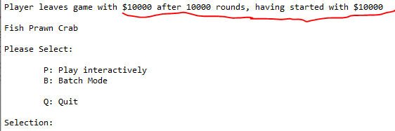

System Cycle 3